**Lesson16 Create Container in .Net**

**Notes:-**

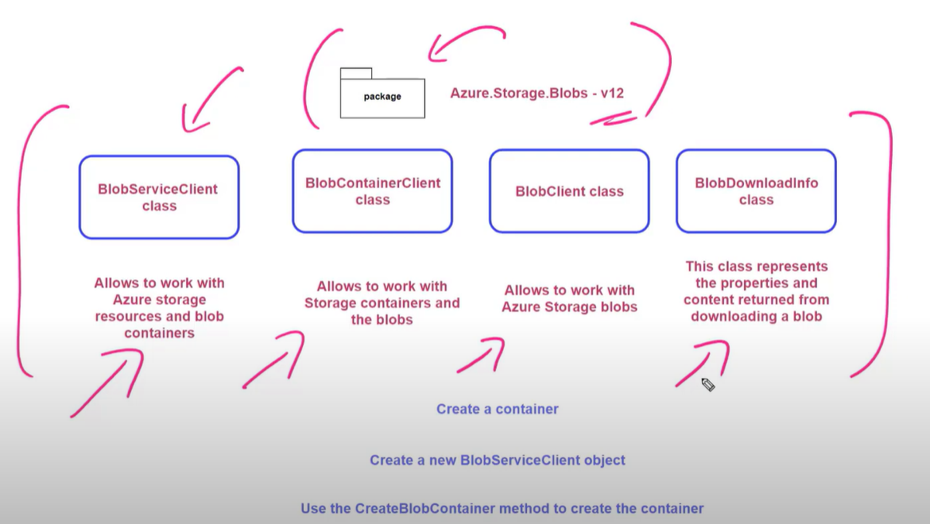

**1-we will create blobServiceClient to access to storage account**

**2-we will create blobContainerClinet to create new container on storage account**